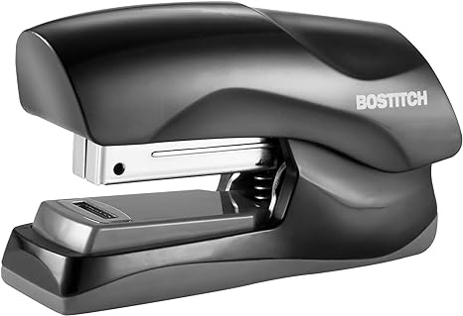

Caran d’Ache Léman Stapler:

The Caran d’Ache Léman Stapler combines timeless design with functionality. Crafted from high-quality materials, it fastens documents seamlessly. As part of the revered Léman collection, it embodies style, luxury, and precisio